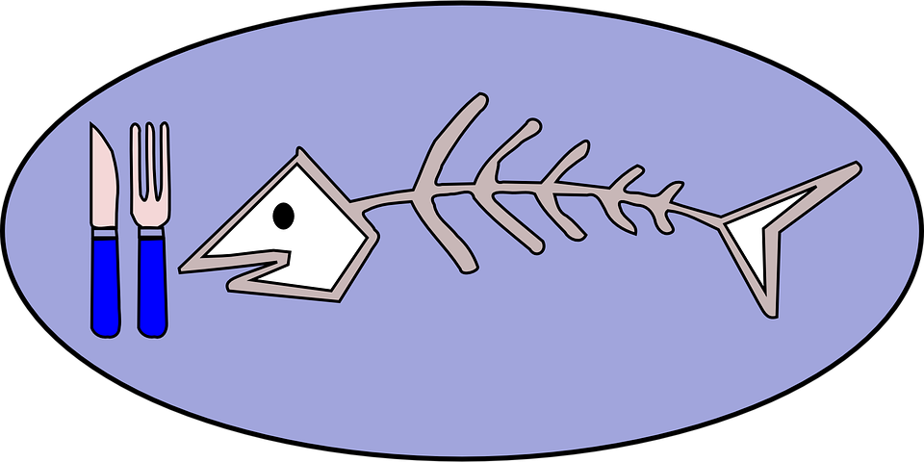
Bone Appétit!
Halloween Inspired Scientific Culinary Competition
Overview

Welcome to Bone Appétit! Halloween Inspired Scientific Culinary Competition created for STEAM Halloween 2020 by members of the Smith College STEAM Outreach Team!

Motivation:

The motivation behind creating this STEAM related opportunity is to provide a fun and easy way to introduce budding scientists into the world of research. Smith College STEAM Outreach, nestled within the Jandon Center for Community Engagement (JCCE), is the proud host of both the high school and middle school Western Massachusetts Science & Engineering Fairs. We wish to support and provide programming to encourage students to delve deeper into concepts related to scientific inquiry by utilizing everyday resources and materials. Our Halloween-inspired Scientific Poster Competition is one way we invite you to become involved!

Overview:

The scientific poster competition is open to everyone and will be divided into two categories:

Adult Category - Single or group entry with scientists over 18 years old
Student/Family Category - Minors with supervision and/or permission of parents

Each poster will be judged by 3 or more adult judges and scores will be averaged. A top prize will be awarded to the highest scoring poster of each category.

Deadline for submission is Halloween Day, October 31st.
Winners will be announced by Friday, November 6th.

Registration:

Registration for the competition requires an adult to complete the following Scientific Culinary Competition Form with participant contact information, category selection, project title, brief abstract, and uploaded poster file. If you experience trouble uploading your file, please contact Deborah Day, STEAM Outreach Coordinator and Chair, Western MA Science & Engineering Fair at dday@smith.edu
Instructions / Methods

- Select any recipe that you would like to modify. We will call this the ‘Original’ Recipe. Note: Your recipe does not have to be Halloween themed but we encourage you to be creative. We will use a cookie recipe here for example and alter the ingredient: butter.
- Identify a meaningful research question related to the recipe whereby you the researcher can change one ingredient to answer the question via data collection. (Ex. What is the impact of substituting applesauce for butter on the height of a cookie?)
- Consider changing one ingredient (variable) in your original recipe. Identify that one ingredient (variable) as your independent variable (IV - ex. butter)
- Research and learn more about your independent variable and how this particular ingredient impacts your recipe chemically and/or physically. What are its attributes? Why is it important? Include chemical properties or make up of the ingredient, if possible.
- Identify one ingredient that you can use in place of the independent variable in your original recipe (ex. Butter replacements such as margarine, applesauce, nut butter, etc. depending on your recipe). We will call the resulting recipe the ‘Experimental Recipe’.
- Research your substitute thoroughly as in step 3 above.
- Consider how you will qualitatively and quantitatively measure the differences in your two recipes. (Qualitative Ex. taste, texture, color, appearance, etc / Quantitative Ex. size of cookie height, circumference, nutritional value etc.)
- Select one quantitative variable (objectively measurable numerical value) to report as your dependent variable (DV).
- Create charts to report your original recipe quantitative and qualitative data. Do the same for your experimental recipe data.
- Before beginning, hypothesize what you think will happen when you substitute the ingredient.
- Follow the original recipe, then, observe, measure, and document your results in your tables. Use metric measurements when possible. Pay special attention to your chosen DV.
- Follow steps 5 & 6 for your experimental recipe (butter substitute, applesauce).
- Analyze your results and consider your dependent variable data for each recipe.
- Report your results including differences and similarities in your recipes.
- Use charts, graphs, tables, etc. to visually represent your results. Also include a textual explanation.
- Draw conclusions from your results. Would you recommend the substituted ingredient? Why or why not? Include specific data from your charts, graphs.
- Discuss limitations to your results and experimental methods. Include improvements which can be made to your methodology or data analysis.
- Use citations from at least three sources. You may use the original recipe as one of your three sources.

Poster Exemplar

Below please find a digital schematic outlining the suggested poster formatting for your entry. Minor deviations from this format are allowed, however, we recommend that you include all of the segments outlined here. Charts, graphs, color scheme, embellishments, and font style can be your choice. The poster should chronologically tell your story from left to right with theoretical information on the left, actual methods and data in the center, and discussion, conclusions, etc. on the right.

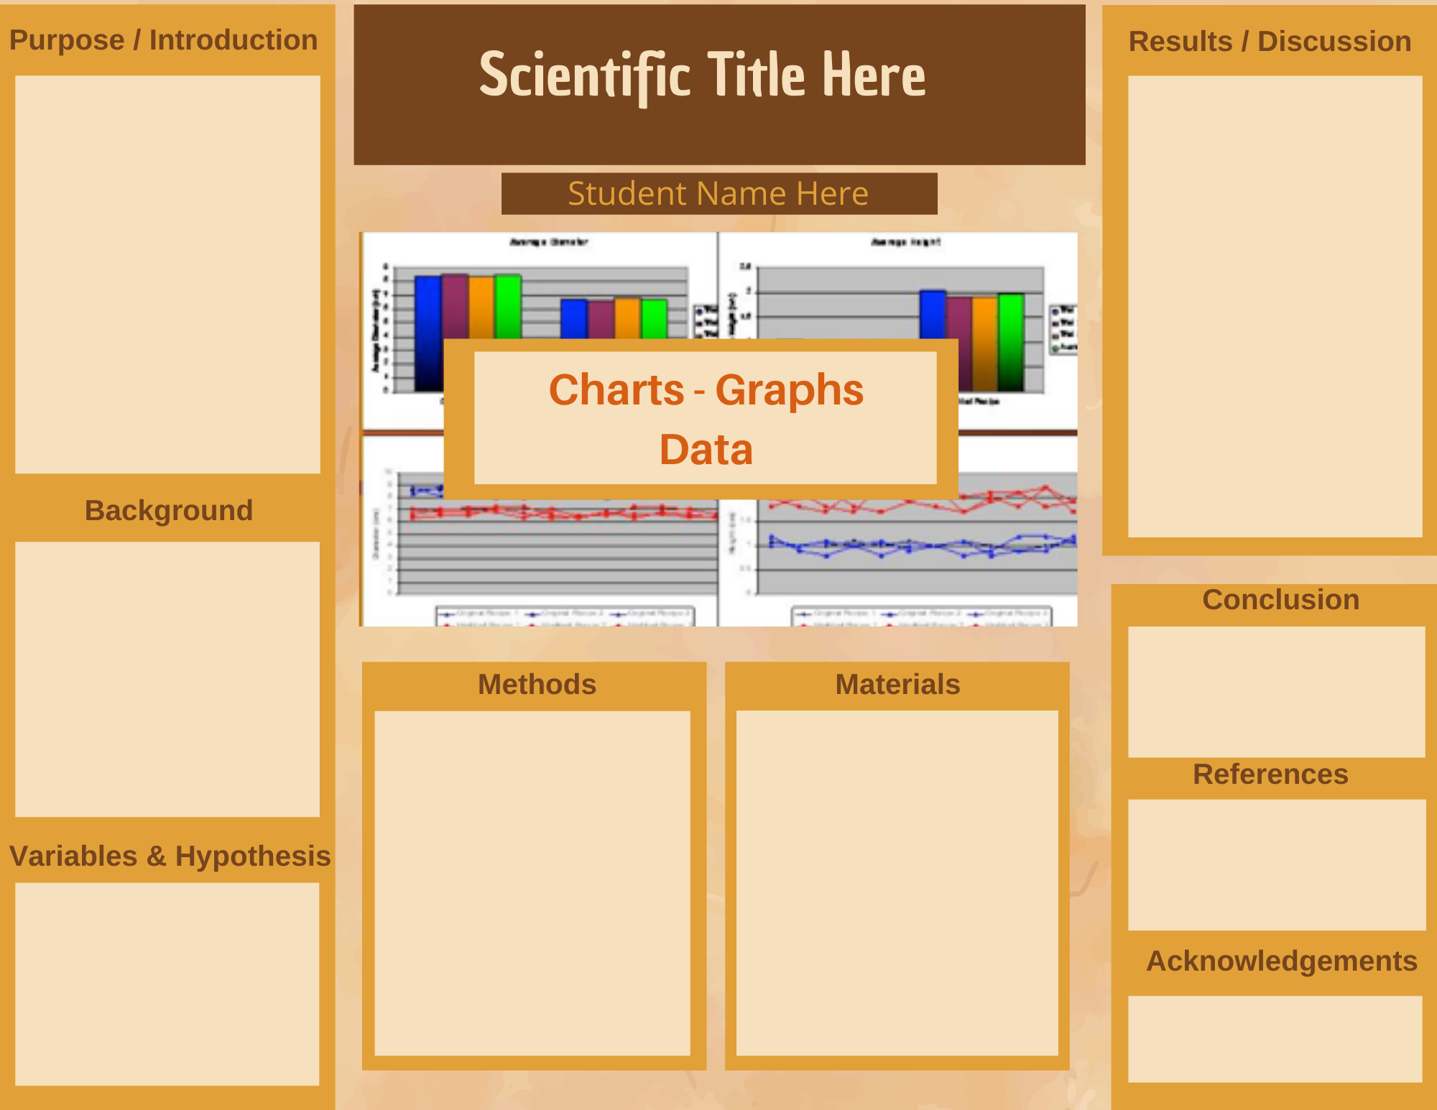

Bone Appétit! Scientific Culinary Competition Rubric
(Needs improvement) 1 2 3 (Excellent)
1. Tri-fold poster design is consistent with the exemplary poster design (provided). | 1 | 2 | 3
2. A scientific title or subtitle that reflects the independent variable and dependent variable. | 1 | 2 | 3
3. The introduction, research question, hypothesis and identification of variables are clearly stated. | 1 | 2 | 3
4. Background information is clear with evidence of literature review. | 1 | 2 | 3
5. Accurate, detailed listings or description of methods and materials are present. | 1 | 2 | 3
6. Data tables showing data collected from both the original and experimental recipes is present (qualitative & quantitative). | 1 | 2 | 3
7. Data is analyzed and displayed in an appropriate graphical format. | 1 | 2 | 3
8. A reasonable and easy to follow discussion is present. | 1 | 2 | 3
9. Conclusions answer the research question and include support data. | 1 | 2 | 3
10. Appropriate citations and/or acknowledgements for research conducted is present. | 1 | 2 | 3
Total Possible Points |  |  | 30

