Fixing Light Pollution in the Pioneer Valley

Dear Homeowner, Manager, or Business Owner,

Your property has a light or lights that are:
☐ unshielded ☐ poorly aimed ☐ excessively bright ☐ excessively blue ☐ ______________

Not all outdoor lighting is the same. Good lighting should be (1) fully shielded, with the light going down only, not out or up; (2) not too blue; and (3) no brighter than necessary. Bad lighting causes glare and light pollution, which benefits no one but wastes energy, is dangerous and unsightly, is linked to health effects ranging from sleep disruption to cancer, is responsible for millions of bird and mammal deaths yearly, and ruins the dark, starry sky. Rule of thumb: light bulbs should not be directly visible except from directly underneath the fixture.

Would you please consider fixing the problem light(s)? Here are some suggested solutions:

☐ Re-aim floodlight so that it shines down only, and not beyond your property line
☐ Replace unshielded incandescent/compact fluorescent light (CFL) bulb with shielded light
☐ Sample shielded LED replacement light (CCT<3500K, <10 watts) provided free of charge
☐ Replace unshielded fixture with fully shielded fixture, or add shield to existing fixture
☐ Replace uplighting with downlighting
☐ Turn lights off when not needed, e.g. 1 hour after close of business, after midnight, etc.
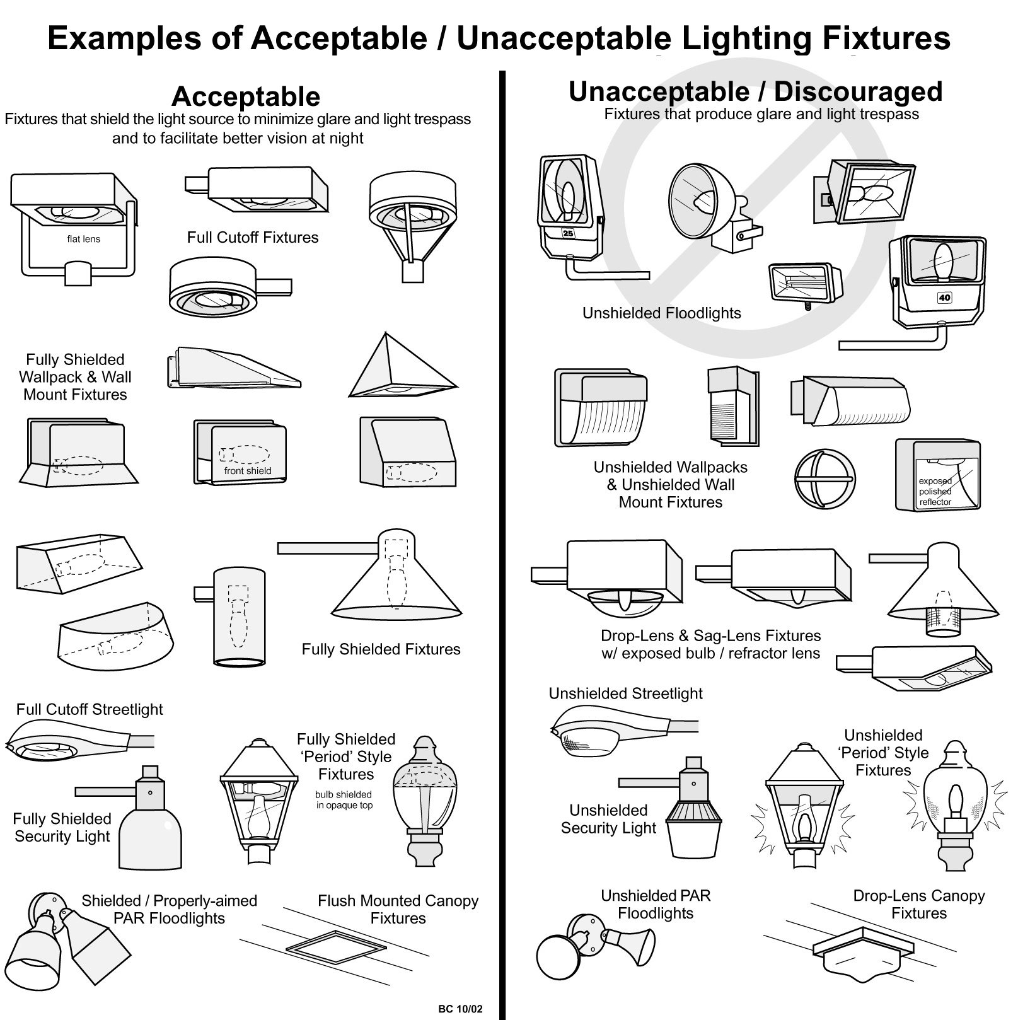
☐ Other: _________________________________________________________________
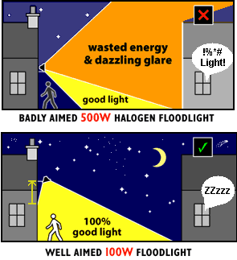
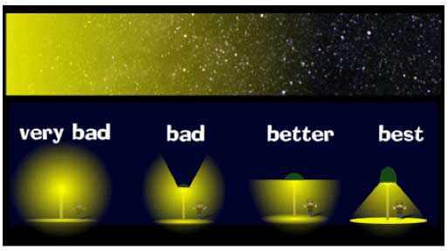

Outdoor Lighting FAQ

Can I still keep my outdoor lighting?
Of course! But please keep the light on your own property, not your neighbor’s. Properly shielded lights provide better visibility. And please turn them off when not needed. Thank you!

What’s the big deal about glare?
Glare (unwanted light shining sideways) makes it harder to see the things you want to see. Glare is especially dangerous when it blinds drivers, bicyclists, and pedestrians. Glare also leads to high contrast and deep shadows that can hide intruders. The elderly are especially sensitive to glare.

What’s especially bad about blue-rich white light?
Blue light disrupts sleep, ruins night vision and causes more glare in the human eye, making it harder to see what you want to see. Blue light also scatters more in the atmosphere: LED lights with correlated color temperature CCT = 5000K (“cool white”) make 7 times more light pollution than LEDs with CCT = 3000K (“warm white”). Most people prefer “warm white” to “white” or “cool white”.

Doesn’t more lighting protect my property from criminals?
No. Scientific studies have found no confirmed link between outdoor lighting and reduced crime. In fact, bad lighting causes glare (see above), which is more dangerous. Safety is enhanced by better lighting, not more lighting.

Is outdoor lighting regulated by law?
Usually. For example, Northampton code Section 350-12.2 requires that all light fixtures shine downward only, with no light escaping above horizontal and no glare (unwanted, sideways-shining light) directed off the property, and specifies maximum permitted illumination levels.

How much will it cost to fix?
Since bad lighting is wasted energy, most fixes that reduce glare and uplighting will save you money. There may be upfront costs for new bulbs or fixtures, but they will usually pay for themselves within a few years. Example: changing a 25W unshielded CFL to a 5W shielded LED ($16) saves $8/year, so it pays for itself in just 2 years (assumes 4000 hrs/yr, 10 cents/KWH).

What are some good, shielded porch light bulbs (for down-facing fixtures only)?
- GE 4.5w PAR16 LED Bulb Dimmable Narrow Flood 180Lm Soft White ($21, Foster Farrar)
- Satco S8997 6w 120v PAR16 3000k E26 FL40 ($21; try http://www.BulbAmerica.com)
- TCP 7W (35W equiv) Warm White LED PAR16 ($14; try www.bulbs.com)

Where can I find good outdoor light fixtures?
Whether you’re shopping online or in a store, look for the Fixture Seal of Approval by the International Dark Sky Association.

Where can I find out more info?
International Dark Sky Association: http://www.darksky.org
Smith College Astronomy Dept.: http://smith.edu/astronomy/
Illuminating Engineering Society of North America: http://www.ies.org

If you don't like the free replacement bulb, just call us and we’ll put the old one back. This handout delivered by: ______________________________________________________

