Real-Time Polymerase Chain Reaction:
This technology has all but replaced Northern blots for determining gene expression in tissues, cells, and organisms with more accuracy and more quantitative capabilities in a much faster format.

Basically you start with a regular PCR reaction and then add fluorescent labels to the mix either with SYBR Green, which non-specifically binds to double stranded DNA, or with a fluorescent probe specific to your amplified sequence. A light source in the Real-Time PCR instrument excites the fluorescence and detects the fluorescent signals. In this way, as amplification proceeds, the fluorescence accumulation is captured in “real-time” by the instrument after every cycle and is translated into a graph that helps you visualize the exponential portion of the amplification. This is the area that gives the most accurate quantification of starting material. Thus, a threshold line is determined in this region and when the fluorescence in the reaction exceeds this line, the Cycle at Threshold (Ct) is determined. It is this value that is used for downstream statistical quantitation.

A great video with lots of visuals of plots and how the fluorescent probes work, reviewing this info, is at:

http://media.invitrogen.com.edgesuite.net/ab/applications-technologies/real-time-pcr/real-time-polymerase-chain-reaction/index.html?ICID=EDI-Lrn1

HOW TO USE THE 7300:
- Make sure you sign up for the 7300 on the HHMI scheduler before setting up your plate.

-Set up reactions in an optical reaction plate from Applied Biosystems covered with adhesive film (Not caps or strip caps! These get jammed in the machine). Set up should be at least in duplicate. I create an excel file of 8 x 12 blank squares to make note of my plate format for my notebook.

- Keep on ice, bring to the 7300. Turn on machine WAIT 15 SECONDS, THEN open up the 7300 software on the desktop, lower left corner.

- Select ‘File’, ‘New’. Choose appropriate application. ‘Relative (ddCt) Plate’ is most common, 96-well format for Container, name your plate (use date in name). Click ‘Next’

-Select a detector. If not in list, click ‘New Detector’ and define it. Then find it in the list and click ‘Add’ then ‘Next’.

-Now select the wells then click on the detector present in the wells. Click ‘Finish’

-Opens up on ‘Plate’ tab. Define your plate with as much or as little detail as you wish. The results will list the well number and letter and the detector, so you decide how much more info you want there.

-Click on the ‘Instrument’ tab. Define the instrument cycles and temperatures. If you need to add a step, click where you would like the step added until a vertical line appears and click ‘Add Step’. Define all temps and times (30 seconds has to be 0:30 with colon manually typed in). Click at end so that vertical line is at the end to let the computer know which steps are included in the cycles. In the boxes below, type in the volume of your reaction and choose which cycle you would like to have the fluorescence accumulation read (usually on the extension step). Write all down in notebook.

-Go to ‘File’ ‘Save’ . The plate name you put in will come up as the suggested file name. The date should be included, trust me. Select where you want it saved. If this is your first time, create a folder for yourself. Do not store on the desktop.

- The start button should not be push-able. Press ‘Start’. Wait for an estimated time to come up to make sure all is well. Return at estimated time (often done 10-20 minutes early).

-Upon return, it should say the program completed successfully. Click ‘OK’. Hit Analyze. Go to ‘Results’ tab, then ‘Amplification Plot’ tab. Select wells to get display of curves. Check out everything needed because this can only be viewed on this computer. Can adjust Threshold line and re analyze if necessary. Once satisfied, select all wells and go to ‘Report’. Then go to ‘File’ ‘Export’ ‘Results’ to export the report to an excel file that you can then work with at your own computer. Save this to your file folder also.

Backup your SDS and excel file onto a jump drive and move all to your computer. Files may be deleted at any time if this computer starts crashing. Will try to leave them on for 6 months for easy use of the software but no promises so BACKUP YOUR DATA.

ANALYSIS:
For absolute quantitation, one has to run a known standard in order to generate a standard curve, and the software will do the calculations for you.

The most common use is for relative quantitation, whereby in addition to your genes of interest, you must also run a series of reactions for a housekeeping gene. For the example below, Universal 18S rRNA was used. The primers were ordered from Ambion and the probe was designed using Primer Express and ordered from IDT.

PRIMER DESIGN
A potential problem with RT-PCR is DNA contamination in RNA. To tell whether amplification is from cDNA template or genomic DNA, RT-PCR primers are usually designed to span introns or bridge an exon-exon junction. When two primers span one or more introns (Fig.1), the amplified product from genomic DNA will be bigger than expected. Primers can also bridge an exon-exon junction (Fig. 2). Such designed primers will not amplify genomic DNA template because the intron will intervene the pairing between the primer and DNA. But, make sure that only a few nucleotides of the 3' portion should pair to the 3' exon as shown in Fig. 2. If the 3' portion of the primer has substantial pairing with the 3' exon, it can still initiate amplification without its 5' portion pairs to the 5' exon (Fig 3. sense primer).
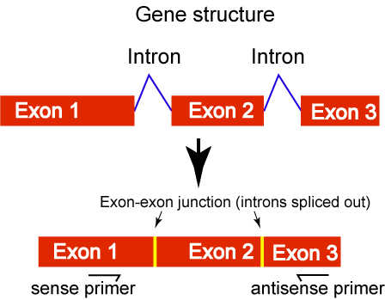 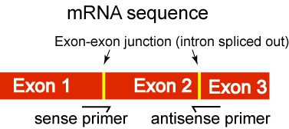
Figure 1. Figure 2.
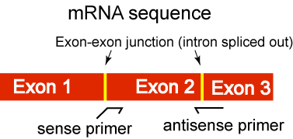
Figure 3
Note that many genes have primer/probe sets commercially available, generally called expression assays. These are more expensive but have a lot more quality control and therefore reliable results than something you may design yourself, though I’ve never had much of a problem with either.
This is how I usually design RT-PCR primers:
I. First get the cDNA sequence of my gene from NCBI. I only use Refseq if available. RefSeq represents the most reliable and unique cDNA sequence for a gene. Because searching the nucleotide database is not effective (you may get hundreds of sequences for a gene, most of them are irrelevant) so I will go to Entrez Gene database (previously LocusLink) at http://www.ncbi.nlm.nih.gov/entrez/query.fcgi?db=gene to find the gene of my interest, then scroll down to the NCBI Reference Sequences (RefSeq) section to find the RefSeq mRNA sequence whose accession number usually looks like NM_xxxxxxx. Then, click the sequence link, which will lead to the actual sequence from GenBank Nucleotide sequence database.
2. Copy the sequence to a program to design primers such as Primer Express on the Gene Pix computer. Just accept all default parameters provided by the program and design primers (or primer/probes). Choose the pair (or trio) with highest score.
3. Copy the sequence corresponding to the amplified region by the primer pair you have chosen and then go to UCSC genome browser at http://genome.ucsc.edu/cgi-bin/hgBlat and paste the sequence there and do a BLAT.
4. Check if the amplicon spans any introns by viewing the detailed alignment of the query sequence against genomic sequence.
5. Or do a BLAT using the whole cDNA sequence first to know where exon-exon junctions (on cDNA) are and then design primers by specifying a target region corresponding to the junctions
6. Another purpose of Blatting amplicon sequence against genome database is to check if the amplified fragment has any homology with other genomic regions. The Blat results will tell that.
7. There are some other places you can also check gene structure such as NCBI Aceview at http://www.ncbi.nlm.nih.gov/IEB/Research/Acembly/index.html and Ensembl at http://www.ensembl.org,
Edit: Sept. 6.
UCSC also provides an in silico PCR tool which allows you to input a pair of primers and retuns potential amplicon targets in the genome. It is useful for checking off-target amplification by your Rt-PCR primers. You can find the tool here: http://genome.ucsc.edu/cgi-bin/hgPcr

Absolute vs Relative Quantification
When calculating the results of your real-time PCR (qPCR) experiment, you can use either absolute or relative quantification.
Absolute vs Relative Quantification at a Glance
 | Absolute Quantification  (Digital PCR Method) | Absolute Quantification  (Standard Curve Method) | Relative Quantification
Overview | In absolute quantification using Digital PCR, no known standards are needed. The target of interest can be directly quantified with precision determined by number of digital PCR replicates. | In absolute quantification using the Standard Curve Method, you quantitate unknowns based on a known quantity. First you create a standard curve; then you compare unknowns to the standard curve and extrapolate a value. | In relative quantification, you analyze changes in gene expression in a given sample relative to another reference sample (such as an untreated control sample).
Example | Quantify copies of rare allele present in heterogenous mixtures.  Count the number of cell equivalents in sample by targeting genomic DNA.  Determine absolute number of viral copies present in a given sample without reference to a standard. | Correlating viral copy number with a disease state. | Measuring gene expression in response to a drug.  In this example, you would compare the level of gene expression of a particular gene of interest in a chemically treated sample relative to the level of gene expression in an untreated sample.

Absolute Quantification Using the Digital PCR Method
Digital PCR works by partitioning a sample into many individual real-time PCR reactions; some portion of these reactions contain the target molecule (positive) while others do not (negative). Following PCR analysis, the fraction of negative answers is used to generate an absolute answer for the exact number of target molecules in the sample, without reference to standards or endogenous controls.
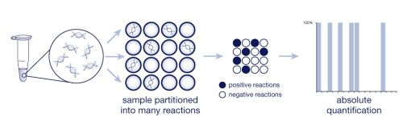
Figure 1:
Digital PCR uses the ratio of positive (White) to negative (Black) PCR reactions
to count the number of target molecules.

Absolute Quantification Using the Standard Curve Method
The standard curve method for absolute quantification is similar to the standard curve method for relative quantification, except the absolute quantities of the standards must first be known by some independent means.
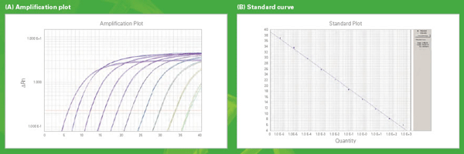
Figure 2:
Amplification Plot and Standard Curve for Absolute Quantification
Critical Guidelines
The guidelines below are critical for proper use of the standard curve method for absolute quantification:
- It is important that the DNA or RNA be a single, pure species. For example, plasmid DNA prepared from E. coli often is contaminated with RNA, which increases the A260 measurement and inflates the copy number determined for the plasmid.
- Accurate pipetting is required because the standards must be diluted over several orders of magnitude. Plasmid DNA or in vitro transcribed RNA must be concentrated in order to measure an accurate A260 value. This concentrated DNA or RNA must then be diluted 106–1012 -fold to be at a concentration similar to the target in biological samples.
- The stability of the diluted standards must be considered, especially for RNA. Divide diluted standards into small aliquots, store at –80 °C, and thaw only once before use.
It is generally not possible to use DNA as a standard for absolute quantification of RNA because there is no control for the efficiency of the reverse transcription step.
Standards
The absolute quantities of the standards must first be known by some independent means. Plasmid DNA and in vitro transcribed RNA are commonly used to prepare absolute standards. Concentration is measured by A260 and converted to the number of copies using the molecular weight of the DNA or RNA.

Relative Quantification
Calculation Methods for Relative Quantification
Relative quantification can be performed with data from all real-time PCR instruments. The calculation methods used for relative quantification are:

- Standard curve method
- Comparative CT method

Which Method Should I Use?
 | Digital PCR Method | Standard Curve Method | Comparative CT Method
Overview | Nucleic acid quantification utilizes theory of limiting sample dilution that is spread across many technical replicate PCR reactions. Absolute quantification is determined by ratio of number of negative versus total reactions. This type of analysis is different from Ct and delta Ct comparisons and instead allows each assayed target to be quantified independently without the need for reference standards. | It is easy to prepare standard curves for relative quantification because quantity is expressed relative to some basis sample (called a calibrator), such as an untreated control.  For all experimental samples, you determine target quantity from the standard curve and divide by the target quantity of the calibrator.  Thus, the calibrator becomes the 1× sample, and all other quantities are expressed as an n-fold difference relative to the calibrator. | This method compares the Ct value of one target gene to another (using the formula: 2^{ΔΔCT})—for example, an internal control or reference gene (e.g., housekeeping gene)—in a single sample.
Advantages | - No need to rely on references or standards  - Desired precision can be achieved by increasing total number of PCR replicates  - Highly tolerant to inhibitors  - Capable of analyzing complex mixtures  - Unlike traditional qPCR, digital PCR provides a linear response to the number of copies present to allow for small fold change differences to be detected | Running the target and endogenous control amplifications in separate tubes and using the standard curve method of analysis requires the least amount of optimization and validation. | - You don't need a standard curve, which can increase throughput because wells no longer need to be used for the standard curve samples. This also eliminates dilution errors made in creating the standard curve samples.  - You can amplify the target and endogenous control in the same tube, increasing throughput and reducing pipetting errors.  - When RNA is the template, performing amplification in the same tube provides some normalization against variables such as RNA integrity and reverse transcription efficiencies.
Experimental Validation | Validated digital PCR results with side by side comparison to well characterized sample with known copy number. | See Advantages above. | You have to run a validation experiment to show that the efficiencies of the target and endogenous control amplifications are approximately equal.  To amplify the target and endogenous control in the same tube, limiting primer concentrations must be identified and shown not to affect CT values.
Critical Guidelines | It is important to use low binding plastics as much as possible throughout experimental set-up. Being that digital PCR emphasizes assaying limiting dilution, any sample that sticks to intermediate set-up equipment will be lost and skew results. We recommend using low binding 2.0mL tubes for dilutions and low-retention pipette tips.  It is important to know the digital area of the desired sample to be tested. If unknown, consult user guide for help in determining copy number of known species (gDNA) or perform a preliminary screening experiment with multiple dilutions of sample/assay combination to determine optimal digital concentration to ensure meaningful data attained.  Sample should not be kept at low concentration for extended periods of time, nor exposed to excessive freeze-thawing. Carriers have not been shown to be as important to reproducibility as much as using non-stick plastics for experimental set-up. Careful planning of dilutions is desired to minimize variability due to dilution scheme. | It is important that stock RNA or DNA be accurately diluted, but the units used to express this dilution are irrelevant. If two-fold dilutions of a total RNA preparation from a control cell line are used to construct a standard curve, the units could be the dilution values 1, 0.5, 0.25, 0.125, and so on. By using the same stock RNA or DNA to prepare standard curves for multiple plates, the relative quantities determined can be compared across the plates.  You can use a DNA standard curve for relative quantification of RNA. Doing this requires the assumption that the reverse transcription efficiency of the target is the same in all samples, but the exact value of this efficiency need not be known.  For quantification normalized to an endogenous control, standard curves are prepared for both the target and the endogenous reference. For each experimental sample, the amount of target and endogenous reference is determined from the appropriate standard curve. Then, the target amount is divided by the endogenous reference amount to obtain a normalized target value. Again, one of the experimental samples is the calibrator, or 1× sample. Each of the normalized target values is divided by the calibrator normalized target value to generate the relative expression levels. | For the comparative CT method to be valid, the efficiency of the target amplification (your gene of interest) and the efficiency of the reference amplification (your endogenous control) must be approximately equal.
Endogenous Control | Digital PCR does not rely on the presence of endogenous controls for reference measurements. | Amplification of an endogenous control may be performed to standardize the amount of sample RNA or DNA added to a reaction. For the quantification of gene expression, researchers have used ß-actin, glyceraldehyde-3-phosphate dehydrogenase (GAPDH), ribosomal RNA (rRNA), or other RNAs as an endogenous control.
Standards | Because Digital PCR uses the fraction of negative to total replicates to determine an absolute count of molecules, no standards are required. | Because the sample quantity is divided by the calibrator quantity, the unit from the standard curve drops out. Thus, all that is required of the standards is that their relative dilutions be known. For relative quantification, this means any stock RNA or DNA containing the appropriate target can be used to prepare standards.

