SeqMan tutorials (Mac)

SeqMan is a sequence assembly tool that lets you assemble anything from two sequences to tens of thousands of sequences into contigs (NOTE: only DNA sequences are applied). This tutorial should be followed in order, as they are designed to walk you through an example SeqMan project from start to finish.

1. Adding multiple sequences to a project

Objective: Create a new project and enter sequences for later assembly.

  - Launch SeqMan by choosing Application>DNASTAR Lasergene v6 > SeqMan . The Unassembled Sequences Window and an empty Project Summary window should appear.

- If the Unassembled Sequences Window does not appear, select FILE>New to open it.

- The Project Summary window will remain empty until after you assemble your sequences.

  - Click Add Sequences at the top of the Unassembled Sequences Window. The Add to Project window appears.

  - Locate and double-click the folder called Demo SeqMan in Application>DNASTAR Lasergene v6. There are 14 sequences in the Demo SeqMan folder. Each of the sequences is a Applied Biosystems, Inc. automated sequencer tracer file.

  - Add all 14 sequences by suing Shift+click to highlight each sequence, then clicking Add File.

  - The Unassembled Sequence window now contains a list of the 14 sequences.

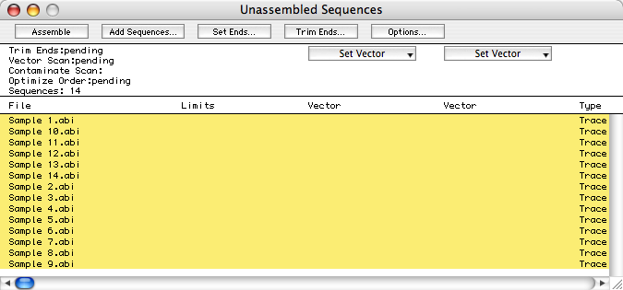

There are other ways to add sequences:

- SEQUENCE > Add or SEQUENCE> Add One;
- “Drag and Drop”
- SEQUENCE > Add Entrez Sequence
- NET SEARCH

2. Preparing sequences for assembly

Objective: Remove Janus vector sequence from the samples and trim sequence ends based on SeqMan’s trace quality evaluation.

  - Select EDIT > Select All to highlight all 14 of the sequences in the Unasssembled Sequences window.

  - Specify the vectors to search for by choosing Janus from one Set Vector list and InvJanus from the other.

- If the desired vector is not included in the list, you can add it to the vector catalog using PROJECT > Vector Catalog.

  - Click Options to open the following dialog. Use this dialog to choose whether to trim poor quality and vector sequence and whether to remove reads containing contaminating sequence.

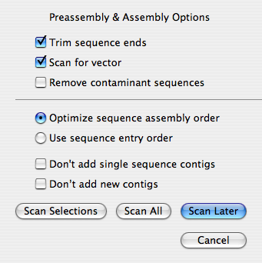
  - Leave he settings as default and click Scan All. SeqMan will scan for the vector you selected, perform quality trimming on sequence ends and establish the optimal sequence assembly order. The Unassembled Sequence window appears. Close it.

- NOTE: Vector column and Limits column.

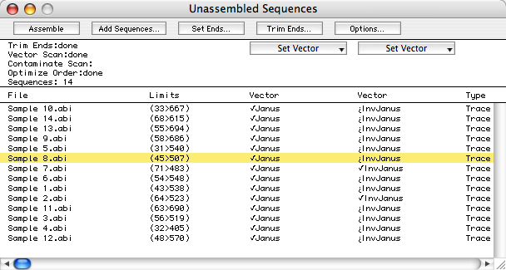

3. Viewing trace data

Objective: View the Trim Report, then examine the Trace Data view for one of the trimmed sequences.

  - Choose PROJECT > Trim Report to open a report showing current end-trimming parameters, followed by the name of each sequences, its average quality, amount trimmed, and both trimmed and pre-trimmed lengths.
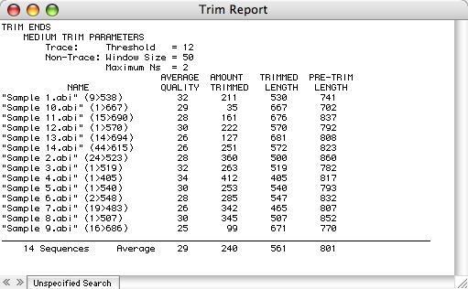

  - Close the report when you are done viewing it.

  - From the Unassembled Sequences window, double-click Sample 8 to open its chromatogram in a separate window.

- The dimmed sequence fragment will not be included during sequence assembly. It is possible to decide to include or not to include sequence fragment in the assembly by dragging the vertical black bar.

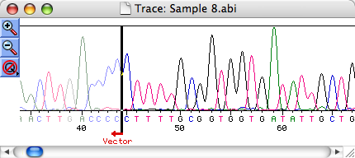

  - Choose EDIT > Go To Position, type 500 into the Position text box and click OK. Note that the peak quality falls in this region, and that beyond base 507, SeqMan determined that average peak quality falls below the medium stringency threshold. This data can be recovered, by simply dragging the bar at the end of the sequence.

  - Close the Trace Data Window.

4. Assembling & checking coverage

Objective: Assemble the 14 sequences, then use the Strategy View to examin the number of conflicts and degree of coverage for the resulting contig.

  - Click Assemble to assemble the 14 sequences in to a single contig. A Report window appears (see 4.2).

- In some cases, you need to modify the assembly parameters. PROJECT > Parameters > Assembling
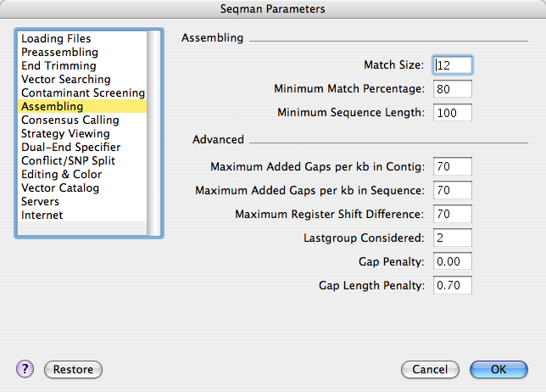

  - Review the data in the Report window and then close that window.

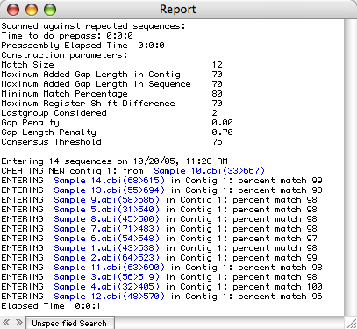

  - In the Porject Summary window, click Contig 1 to select it and choose CONTIG > Strategy View to open the following window.

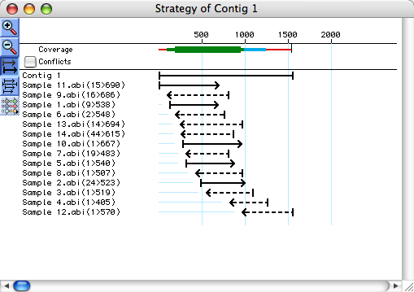

  - Enlarge the Strategy View by dragging its lower right corner down to view all of the samples.

  - The colorful band summarizing sequencing coverage. The color and thickness of the band represent the amount of coverage.

  - The thick green bank that appears (200 – 900) denotes a region sequences on both strands and above the minimum coverage threshold. (This threshold may be adjusted using PROJECT > Parameters > Strategy Viewing).

  - The medium blue line (900 -1100) denotes a region sequences in one direction only.

  - The thin red line appearing at each end of the contig means the region was only sequenced once.

  - Check the Conflicts box at the top left of the window to view a histogram showing agreement between fragment sequences. This histogram appears mostly black, indicating little or no conflict in most areas. Several dark blue bands indicate regions where conflicts occur in 10-20% of the bases.

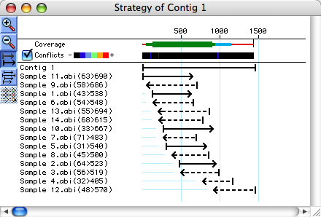

5. Comparing consensi & restoring sequence ends

Objectives: Use the Alignment View to restore trimmed ends manually and to compare the results of two consensus calculation methods.

  - From the Strategy View, double-click on the first blue stripe on the left on the Conflicts histogram (near base 50). This opens the Alignment View for that region. The Alignment View displays the consensus sequence at the top of the window, with constituent sequences listed in the lower part.

  - Click on the triangle to the left of the word “Consensus” to compare two consensi calculated using different methods. A line open under the original consensus, and the names of the calculation methods are displayed. Any differences between the primary method (“Trace”) and comparison method (“Majority”) appear in red.

  - In the list of constituent sequences, note that Sample 9 has a few conflicts, indicated in red. View the underlying trace data for Sample 9 by clicking on the triangle to the left of the sequence name.

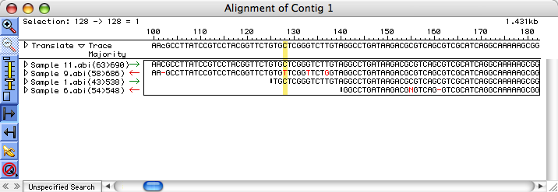

  - Restore data to the Sample 9 sequence by staging the left trim bar. Note that the preciously trimmed sequence is marked in bright yellow background. Drag the trim bar to approximately “0”.

  - Restoring trimmed sequence often reveals conflicts between the restored data and the consensus sequence.

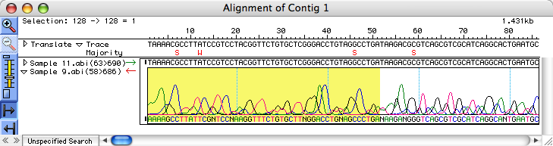

  - In order to view conflicts in the newly-restored sequence more easily, you need to close the trace data by once again clicking on the dark triangle to the left of Sample 9.

  - The red letters in the leftmost portion of the Sample 9 sequence indicate conflicts between the restored data and the consensus. In this case, sequence had originally been trimmed due to inferior peak quality. Sometimes, it is beneficial to restore such data. However, data removed due to vector contamination would have been characterized by normal peak quality in combination with a high number of conflicts. Regardless of its deceptively high peak quality, it is not recommended that you restore vector data.

  - “Trace” consensus call is often superior to the simple “Majority” consensus. For example, at position “46”, the “Trace” consensus call remains G even though the sample 9 call is C. That’s because the “Trace” method judges the peak quality, while the “Majority” method (which calls S) does not get the correct consensus here.

  - Open the trace data for Sample 9 again and slide the trim bars until the trimmed (highlighted) data are no longer visible.

  - Close the Strategy View Window.

- Finding possible conflict or SNP locations

Objective: Locate conflicts or possible SNPs in the contig.

  - Single-click on the contig name in the Project Summary window.

  - Choose CONTIG > Suggest Conflict/SNP Splits to open the following enhanced Alignment View window showing the single proposed split. This special type of Alignment View has buttons that enable you to Cancel the suggestion or Split the contig. Color-coded boxes to the left of the sequences indicate which reads will be assigned to each new contig if you execute the split. Exam the Alignment window.

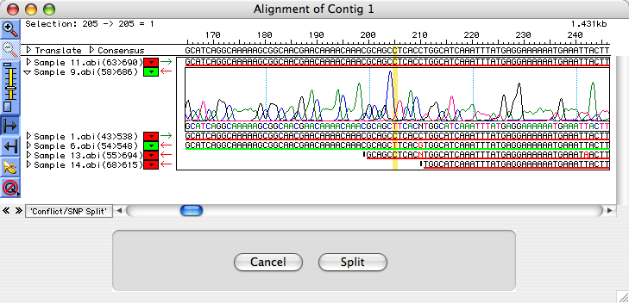

  - Click Cancel to return the normal Alignment View without splitting the contig. NOTE: you cannot “undo” the split.

- Editing sequences and consensi

Objective: Practice editing sequences in the Alignment View.

  - In the Alignment View window, you can do the following to edit the sequences.

- To edit a constituent or consensus sequence, highlight the bases (s) or the insertion point where you wish to edit and type in the desired changes.

- Gaps may be inserted by typing dashes (-), while deletions may be made using Delete.

- Changes made to a consensus affect it and all of its constituent sequences, while changes made to a constituent sequence only affect the consensus if there is little coverage in that area.

  - Select EDIT > Find to locate a conflict.

  - Type a dash (-) into the text box and leave other settings at their default values.

  - Click Find Next. SeqMan finds the first gap and the Find dialog closes.

  - Click Find Next or Find Previous to locate conflicted gaps. At position “306”, Sample 7 reports a “T”, while all other samples register it as a gap. Which one shall we use? You can resolve this conflict by viewing the trace data for Sample 7.

  - Highlight position 306 including the consensus and all of its constituent sequences.

  - Reveal the trace data of Sample 7 (How? You should have known by now.)

  - Zoom the chromatogram by clicking . The trace data show that the “T” in Sample 7 is probably an artifact, as is the ”A” to its left.

  - Note: although it is to the left, it is downstream, because the read is the complementary strand.

  - You can see from the consensus sequence that SeqMan’s trace quality evaluation algorithm has automatically ignored both of these dubious bases. It is not necessary, therefore, to correct the sequence data by manually editing out the bases. However, you can experiment by replacing the “TY” with a gap, then removing the column of gaps from the consensus by continuing to the next step.

  - Hide the trace data of Sample 7.

  - Highlight the letter “T” at position 306 and replace it by typing a gap (dash).

  - Highlight an area of the consensus that includes position 306 and choose EDIT > Remove Consensus Gaps. All gaps at position 306 disappear.

- Alternatively, you could highlight the gap in the consensus sequence and press Delete.

  - Scroll down the entire contig to find more such conflicted gaps, remove the gaps if necessary.

- Saving consensus sequence and save / export an assembly project

Objectives: Save the consensus sequence and save the SeqMan file for future analysis.

  - Select CONTIG > Save Consensus > Single File

  - In the Save window, you can choose the format from the following five options: Lasergene DNA File, FastA, GenBank Flat File, GCG File, Extended FastA.

  - In the Save window, make sure you choose “Bases All” instead “From __ To __”. In the latter case, only specified region will be saved.

  - Select FILE > Save As to save the SeqMan to save this assembly project.

  - Select File > Export Project to export a SeqMan assembly project to either Phrap assembly or DOS SeqMan assembly formats.

A few more things:

- Change Contig name
- Project > Statistics
- Multiple contigs
- Translate
- “banana” tool

